SINDH INSTITUTE OF PHYSICAL MEDICINE

Affix
Passport Size Photo
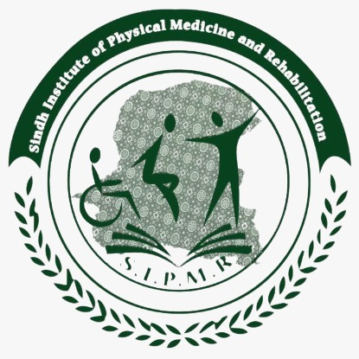
& REHABILITATION
KARACHI

APPLICATION FORM FOR VISITING FACULTY

POST APPLIED FOR:
SPECIALITY
DATE OF ADVERTISEMENT
DATE OF APPLICATION

1.PERSONAL DETAILS

NAME
FATHER’S/HUSBAND’S NAME
DATE OF BIRTH
AGE ON CLOSING DATE YY MM DD
SEX M/F MARITAL STATUS
ADDRESS
_________________________________________________________________
City _______________ Province/State ____________Country ______________
Area Code_______________________
Telephone Residence______________Mobile ___________ Clinic____________
EMAIL
PERMANENT ADDRESS (If different from above)_____________________________ ________________________________________________________________________
City _____________ Province/State ____________Country _____________
Area Code_______________________

DOMICILE ___________________

CNIC NUMBER ______________
PMDC NUMBER _____________

2.CURRENT APPOINTMENT

3.ACADEMIC PROFILE
(Most recent first)

DEGREE/DIPLOMA/CERTIFICTE YEAR INSTITUTION
1.
2.
3.
4.
5.
6
(Further details on extra sheet)

4.ACADEMIC HONOURS AND AWARDS

1.
2.
3.
4.
5.
6.

5.EXPERIENCE
(Most recent first)
Post Institution Date From To
1.
2.
3.
4.
5.
6.
7.
8.
9.
10.
11.
12.
(Further details on extra sheet)

6.RESEARCH PAPERS,DISSERTATIONS AND PUBLICATIONS
(Mention all papers you wish to be given credit of. No credit will be given to papers not listed in this application form)

(Further Details on Extra Sheet)

7.WORKSHOPS & TRAINING COURSES
Name Venue Year

8.ANY OTHER

9.RESEARCH AND ACADEMIC INTERESTS

10.REFERENCES
(Must include the most recent superior)

- Name __________________________
Designation _____________________
Address ________________________
________________________
Tel No. _________________________
e-Mail __________________________

2. Name __________________________
Designation _____________________
Address ________________________
________________________
Tel No. _________________________
e-Mail __________________________

- Name __________________________
Designation _____________________
Address ________________________
________________________
Tel No. _________________________
e-Mail __________________________

Enclosures
Three passport size photographs in addition to the one already affixed
attested photocopies of
- CNIC
- PMDC Valid Certificate
- All Educational documents Matric Certificate, Degree, Postgraduate diplomas and Certificates.
- Experience Certificates
- PMDC recognition of Experience
- PMDC recognition of Qualification
- Domicile & PRC-Form-D (If it is a precondition of the post)
- Copies of all publications to be considered for credit
- Certificates of Workshops /Courses etc
Note: All the original documents, including publications, to be brought at the time of interview

